Chapter 8, Solution 7.

α = [R/(2L)] = 20x10³/(2x0.2x10^{–3}) = 50x10⁶

ω_{o} = [1/(LC)^{0.5}] = 1/(0.2x10^{–3}x5x10^{–6})^{0.5} = 3.162 x10⁴

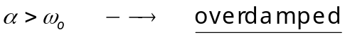

overdamped

